# Bactria-Margiana Archaeological Complex

The **Bactria–Margiana Archaeological Complex** (or **BMAC**, also known as the **Oxus civilisation**) is the modern archaeological designation for a [Bronze Age](https://en.wikipedia.org/wiki/Bronze_Age) [civilisation](https://en.wikipedia.org/wiki/Civilisation) of [Central Asia](https://en.wikipedia.org/wiki/Central_Asia), dated to ca. 2300–1700 BCE, located in present-day northern [Afghanistan](https://en.wikipedia.org/wiki/Afghanistan), eastern [Turkmenistan](https://en.wikipedia.org/wiki/Turkmenistan), southern [Uzbekistan](https://en.wikipedia.org/wiki/Uzbekistan) and western [Tajikistan](https://en.wikipedia.org/wiki/Tajikistan), centred on the upper [Amu Darya](https://en.wikipedia.org/wiki/Amu_Darya) (Oxus River). Its sites were discovered and named by the [Soviet](https://en.wikipedia.org/wiki/Soviet_Union) archaeologist [Viktor Sarianidi](https://en.wikipedia.org/wiki/Viktor_Sarianidi) (1976). [*Bactria*](https://en.wikipedia.org/wiki/Bactria) was the Greek name for the area of *Bactra* (modern [Balkh](https://en.wikipedia.org/wiki/Balkh)), in what is now northern Afghanistan, and *Margiana* was the Greek name for the Persian [satrapy](https://en.wikipedia.org/wiki/Satrapy) of [Margu](https://en.wikipedia.org/wiki/Margu), the capital of which was [Merv](https://en.wikipedia.org/wiki/Merv), in modern-day southeastern Turkmenistan.

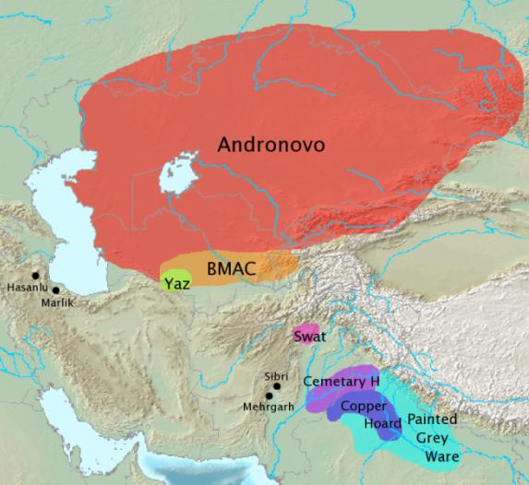

Archaeological cultures associated with [Indo-Iranian migrations](https://en.wikipedia.org/wiki/Indo-Iranian_migration) (after [Mallory](https://en.wikipedia.org/wiki/Encyclopedia_of_Indo-European_Culture) and Adams 1997). The [Andronovo](https://en.wikipedia.org/wiki/Andronovo_culture), BMAC and [Yaz cultures](https://en.wikipedia.org/wiki/Yaz_culture) have often been associated with [Indo-Iranian](https://en.wikipedia.org/wiki/Indo-Iranians) migrations. The [GGC](https://en.wikipedia.org/wiki/Gandhara_grave_culture) (Swat), [Cemetery H](https://en.wikipedia.org/wiki/Cemetery_H_culture), [Copper Hoard](https://en.wikipedia.org/wiki/Copper_Hoard_Culture) and [PGW](https://en.wikipedia.org/wiki/Painted_Grey_Ware_culture) cultures are candidates for cultures associated with [Indo-Aryan](https://en.wikipedia.org/wiki/Indo-Aryan_peoples) [migrations](https://en.wikipedia.org/wiki/Indo-Aryan_migration).After CC BY-SA 3.0, https://commons.wikimedia.org/w/index.php?curid=868992

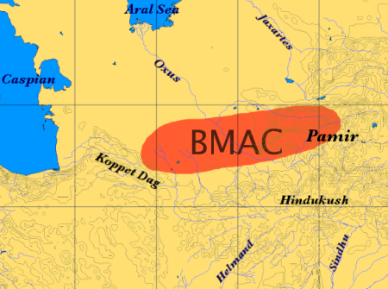

There is archaeological evidence of settlement in the well-watered northern foothills of the [Kopet Dag](https://en.wikipedia.org/wiki/Kopet_Dag) during the [Neolithic](https://en.wikipedia.org/wiki/Neolithic) period. This region is dotted with the multi-period hallmarks characteristic of the ancient Near East, similar to those southwest of the Kopet Dag in the [Gorgan](https://en.wikipedia.org/wiki/Gorgan) Plain in Iran.[[2]](https://en.wikipedia.org/wiki/Bactria-Margiana_Archaeological_Complex" \l "cite_note-FOOTNOTEKohl2007189.E2.80.93190-2) At Jeitun (or Djeitun), mud brick houses were first occupied c. 6000 BCE. The inhabitants were farmers who kept herds of goats and sheep and grew wheat and barley, with origins in southwest Asia.[[3]](https://en.wikipedia.org/wiki/Bactria-Margiana_Archaeological_Complex" \l "cite_note-3) Jeitun has given its name to the whole Neolithic period in the northern foothills of the Kopet Dag. At the late Neolithic site of Chagylly Depe, farmers increasingly grew the kinds of crops that are typically associated with irrigation in an arid environment, such as hexaploid bread wheat, which became predominant during the [Chalcolithic](https://en.wikipedia.org/wiki/Chalcolithic) period.[[4]](https://en.wikipedia.org/wiki/Bactria-Margiana_Archaeological_Complex" \l "cite_note-4)

During the Copper Age, the population of this region grew. Archaeologist Vadim Mikhaĭlovich Masson, who led the South Turkmenistan Complex Archaeological Expedition from 1946, sees signs that people migrated to the region from central Iran at this time, bringing metallurgy and other innovations, but thinks that the newcomers soon blended with the Jeitun farmers.[[5]](https://en.wikipedia.org/wiki/Bactria-Margiana_Archaeological_Complex" \l "cite_note-MassonThe-5) By contrast a re-excavation of Monjukli Depe in 2010 found a distinct break in settlement history between the late neolithic and early chalcolithic eras there.[[6]](https://en.wikipedia.org/wiki/Bactria-Margiana_Archaeological_Complex" \l "cite_note-6)

Major chalcolithic settlements sprang up at [Kara-Depe](https://en.wikipedia.org/w/index.php?title=Kara_Depe&action=edit&redlink=1) and [Namazga-Depe](https://en.wikipedia.org/wiki/Namazga-Tepe). In addition, there were smaller settlements at [Anau](https://en.wikipedia.org/wiki/Anau), Dashlyji, and [Yassy-depe](https://en.wikipedia.org/w/index.php?title=Yassy_Depe&action=edit&redlink=1). Settlements similar to the early level at Anau also appeared further east– in the ancient delta of the river [Tedzen](https://en.wikipedia.org/wiki/Tejen_River), the site of the [Geoksiur](https://en.wikipedia.org/w/index.php?title=Geoksiur&action=edit&redlink=1) Oasis. About 3500 BCE the cultural unity of the area split into two pottery styles: colourful in the west (Anau, Kara-Depe and Namazga-Depe) and more austere in the east at [Altyn-Depe](https://en.wikipedia.org/wiki/Altyn-Depe) and the Geoksiur Oasis settlements. This may reflect the formation of two tribal groups. It seems that around 3000 BCE people from Geoksiur migrated into the [Murghab](https://en.wikipedia.org/wiki/Murghab_River) delta, where small, scattered settlements appeared, and reached further east into the [Zerafshan](https://en.wikipedia.org/wiki/Zeravshan_River) Valley in [Transoxiana](https://en.wikipedia.org/wiki/Transoxiana). In both areas pottery typical of Geoksiur was in use. In Transoxiana they settled at [Sarazm](https://en.wikipedia.org/wiki/Sarazm) near [Pendjikent](https://en.wikipedia.org/wiki/Panjakent). To the south the foundation layers of [Shahr-i Shōkhta](https://en.wikipedia.org/wiki/Shahr-e_Sukhteh) on the bank of the [Helmand](https://en.wikipedia.org/wiki/Helmand_River) river in south-eastern Iran contained pottery of the Altyn-Depe and Geoksiur type. Thus the farmers of Iran, Turkmenistan and Afghanistan were connected by a scattering of farming settlements.[[5]](https://en.wikipedia.org/wiki/Bactria-Margiana_Archaeological_Complex" \l "cite_note-MassonThe-5)

In the Early Bronze Age the culture of the Kopet Dag oases and Altyn-Depe developed a proto-urban society. This corresponds to level IV at Namazga-Depe. Altyn-Depe was a major centre even then. Pottery was wheel-turned. Grapes were grown. The height of this urban development was reached in the Middle Bronze Age c. 2300 BCE, corresponding to level V at Namazga-Depe.[[5]](https://en.wikipedia.org/wiki/Bactria-Margiana_Archaeological_Complex" \l "cite_note-MassonThe-5) It is this Bronze Age culture which has been given the BMAC name.

The inhabitants of the BMAC were sedentary people who practised [irrigation](https://en.wikipedia.org/wiki/Irrigation) farming of [wheat](https://en.wikipedia.org/wiki/Wheat) and [barley](https://en.wikipedia.org/wiki/Barley). With their impressive material culture including monumental architecture, bronze tools, ceramics, and jewellery of semiprecious stones, the complex exhibits many of the [hallmarks](https://en.wikipedia.org/wiki/Civilization" \l "What_characterizes_civilization) of [civilisation](https://en.wikipedia.org/wiki/Civilisation). The complex can be compared to proto-urban settlements in the [Helmand](https://en.wikipedia.org/wiki/Helmand) basin at [Mundigak](https://en.wikipedia.org/wiki/Mundigak) in western Afghanistan and [Shahr-i Shōkhta](https://en.wikipedia.org/wiki/Shahr-i_Shōkhta) in eastern Iran, or at [Harappa](https://en.wikipedia.org/wiki/Harappa) and [Mohenjo-daro](https://en.wikipedia.org/wiki/Mohenjo-daro) in the Indus Valley.[[7]](https://en.wikipedia.org/wiki/Bactria-Margiana_Archaeological_Complex" \l "cite_note-FOOTNOTEKohl2007186.E2.80.93187-7)

Sarianidi regards [Gonur](https://en.wikipedia.org/wiki/Gonur_Tepe) as the "capital" of the complex in Margiana throughout the Bronze Age. The palace of north Gonur measures 150 metres by 140 metres, the temple at [Togolok](https://en.wikipedia.org/w/index.php?title=Togolok&action=edit&redlink=1) 140 metres by 100 metres, the fort at [Kelleli](https://en.wikipedia.org/w/index.php?title=Kelleli&action=edit&redlink=1) 3 125 metres by 125 metres, and the house of a local ruler at [Adji Kui](https://en.wikipedia.org/w/index.php?title=Adji_Kui&action=edit&redlink=1) 25 metres by 25 metres. Each of these formidable structures has been extensively excavated. While they all have impressive fortification walls, gates, and buttresses, it is not always clear why one structure is identified as a temple and another as a palace.[[8]](https://en.wikipedia.org/wiki/Bactria-Margiana_Archaeological_Complex" \l "cite_note-LambergKarlovskyArchaeology-8) [Mallory](https://en.wikipedia.org/wiki/J._P._Mallory) points out that the BMAC fortified settlements such as Gonur and Togolok resemble the [qala](https://en.wikipedia.org/wiki/Qila), the type of fort known in this region in the historical period. They may be circular or rectangular and have up to three encircling walls. Within the forts are residential quarters, workshops and temples.[[9]](https://en.wikipedia.org/wiki/Bactria-Margiana_Archaeological_Complex" \l "cite_note-FOOTNOTEMalloryAdams199772-9)

The people of the BMAC culture were very proficient at working in a variety of metals including bronze, copper, silver, and gold. This is attested through the many metal artefacts found throughout the sites.

Extensive irrigation systems have been discovered at the Geoksiur Oasis.[[5]](https://en.wikipedia.org/wiki/Bactria-Margiana_Archaeological_Complex" \l "cite_note-MassonThe-5)

Models of two-wheeled carts from c. 3000 BCE found at Altyn-Depe are the earliest complete evidence of wheeled transport in Central Asia, though model wheels have come from contexts possibly somewhat earlier. Judging by the type of harness, carts were initially pulled by oxen, or a bull. However camels were domesticated within the BMAC. A model of a cart drawn by a camel of c. 2200 BCE was found at Altyn-Depe.[[10]](https://en.wikipedia.org/wiki/Bactria-Margiana_Archaeological_Complex" \l "cite_note-10)

The discovery of a single tiny stone [seal](https://en.wikipedia.org/wiki/Seal_(device)) (known as the "Anau seal") with geometric markings from the BMAC site at Anau in Turkmenistan in 2000 led some to claim that the [Bactria](https://en.wikipedia.org/wiki/Bactria)-[Margiana](https://en.wikipedia.org/wiki/Margiana) complex had also developed [writing](https://en.wikipedia.org/wiki/Writing), and thus may indeed be considered a literate civilisation. It bears five markings strikingly similar to Chinese "small seal" characters, but such characters date from the Qin reforms of roughly 100 AD, while the Anau seal is dated by context to 2,300 BCE. It is therefore an unexplained anomaly. The only match to the Anau seal is a small jet seal of almost identical shape from Niyä (near modern Minfeng) along the southern Silk Road in Xinjiang, assumed to be from the Western Han dynasty.[[11]](https://en.wikipedia.org/wiki/Bactria-Margiana_Archaeological_Complex" \l "cite_note-11)

## Interactions with other cultures

BMAC materials have been found in the [Indus](https://en.wikipedia.org/wiki/Indus_Valley_Civilization) civilisation, on the [Iranian plateau](https://en.wikipedia.org/wiki/Iranian_plateau), and in the [Persian Gulf](https://en.wikipedia.org/wiki/Persian_Gulf).[[8]](https://en.wikipedia.org/wiki/Bactria-Margiana_Archaeological_Complex" \l "cite_note-LambergKarlovskyArchaeology-8) Finds within BMAC sites provide further evidence of trade and cultural contacts. They include an Elamite-type cylinder seal and a [Harappan](https://en.wikipedia.org/wiki/Harappa) seal stamped with an elephant and Indus script found at Gonur-depe.[[12]](https://en.wikipedia.org/wiki/Bactria-Margiana_Archaeological_Complex" \l "cite_note-FOOTNOTEKohl2007196.E2.80.93199-12) The relationship between Altyn-Depe and the Indus Valley seems to have been particularly strong. Among the finds there were two [Harappan](https://en.wikipedia.org/wiki/Harappa) seals and ivory objects. The Harappan settlement of [Shortugai](https://en.wikipedia.org/wiki/Shortugai) in Northern Afghanistan on the banks of the [Amu Darya](https://en.wikipedia.org/wiki/Amu_Darya) probably served as a trading station.[[5]](https://en.wikipedia.org/wiki/Bactria-Margiana_Archaeological_Complex" \l "cite_note-MassonThe-5)

There is evidence of sustained contact between the BMAC and the Eurasian steppes to the north, intensifying c. 2000 BCE. In the delta of the [Amu Darya](https://en.wikipedia.org/wiki/Amu_Darya) where it reaches the [Aral Sea](https://en.wikipedia.org/wiki/Aral_Sea), its waters were channelled for irrigation agriculture by people whose remains resemble those of the nomads of the [Andronovo Culture](https://en.wikipedia.org/wiki/Andronovo_Culture). This is interpreted as nomads settling down to agriculture, after contact with the BMAC. The culture they created is known as [Tazabag'yab](https://en.wikipedia.org/wiki/Tazabagyab_culture).[[13]](https://en.wikipedia.org/wiki/Bactria-Margiana_Archaeological_Complex" \l "cite_note-FOOTNOTEKohl2007Chapter_5-13) About 1800 BCE, the walled BMAC centres decreased sharply in size. Each oasis developed its own types of pottery and other objects. Also pottery of the Andronovo-Tazabag'yab culture to the north appeared widely in the Bactrian and Margian countryside. Many BMAC strongholds continued to be occupied and Andronovo-Tazabagyab coarse incised pottery occurs within them (along with the previous BMAC pottery) as well as in pastoral camps outside the mudbrick walls. In the highlands above the Bactrian oases in Tajikistan, [kurgan](https://en.wikipedia.org/wiki/Kurgan) cemeteries of the Vaksh and Bishkent type appeared with pottery that mixed elements of the late BMAC and Andronovo-Tazabagyab traditions.[[14]](https://en.wikipedia.org/wiki/Bactria-Margiana_Archaeological_Complex" \l "cite_note-DavidAnthony-14)

## Language

As argued by [Michael Witzel](https://en.wikipedia.org/wiki/Michael_Witzel)[[15]](https://en.wikipedia.org/wiki/Bactria-Margiana_Archaeological_Complex" \l "cite_note-15)[[16]](https://en.wikipedia.org/wiki/Bactria-Margiana_Archaeological_Complex" \l "cite_note-Witzel_2003-16) and Alexander Lubotsky,[[17]](https://en.wikipedia.org/wiki/Bactria-Margiana_Archaeological_Complex" \l "cite_note-17) there is a proposed [substratum](https://en.wikipedia.org/wiki/Substratum) in [Proto-Indo-Iranian](https://en.wikipedia.org/wiki/Proto-Indo-Iranian) which can be plausibly identified with the original language of the BMAC. Moreover, Lubotsky points out a larger number of words apparently borrowed from the same language, which are only attested in [Indo-Aryan](https://en.wikipedia.org/wiki/Indo-Aryan_languages) and therefore evidence of a [substratum in Vedic Sanskrit](https://en.wikipedia.org/wiki/Substratum_in_Vedic_Sanskrit). Some BMAC words have now also been found in [Tocharian](https://en.wikipedia.org/wiki/Tocharian_languages).[[18]](https://en.wikipedia.org/wiki/Bactria-Margiana_Archaeological_Complex" \l "cite_note-18) Michael Witzel points out that the borrowed vocabulary includes words from agriculture, village and town life, flora and fauna, ritual and religion, so providing evidence for the acculturation of Indo-Iranian speakers into the world of urban civilisation.[[16]](https://en.wikipedia.org/wiki/Bactria-Margiana_Archaeological_Complex" \l "cite_note-Witzel_2003-16)

## Relationship with Indo-Iranians

See also: [Indo-Aryan migration theory](https://en.wikipedia.org/wiki/Indo-Aryan_migration_theory)

The Bactria-Margiana complex has attracted attention as a candidate for those looking for the material counterparts to the [Indo-Iranians](https://en.wikipedia.org/wiki/Indo-Iranians) (Aryans), a major linguistic branch that split off from the [Proto-Indo-Europeans](https://en.wikipedia.org/wiki/Proto-Indo-Europeans). Sarianidi himself advocates identifying the complex as Indo-Iranian, describing it as the result of a migration from southwestern Iran. Bactria–Margiana material has been found at Susa, Shahdad, and [Tepe Yahya](https://en.wikipedia.org/wiki/Tepe_Yahya) in Iran, but Lamberg-Karlovsky does not see this as evidence that the complex originated in southeastern Iran. "The limited materials of this complex are intrusive in each of the sites on the Iranian Plateau as they are in sites of the Arabian peninsula."[[8]](https://en.wikipedia.org/wiki/Bactria-Margiana_Archaeological_Complex" \l "cite_note-LambergKarlovskyArchaeology-8)

A significant section of the archaeologists are more inclined to see the culture as begun by farmers in the Near Eastern [Neolithic](https://en.wikipedia.org/wiki/Neolithic) tradition, but infiltrated by Indo-Iranian speakers from the Andronovo culture in its late phase, creating a hybrid. In this perspective, [Proto-Indo-Aryan](https://en.wikipedia.org/wiki/Proto-Indo-Aryan) developed within the composite culture before moving south into the Indian subcontinent.[[14]](https://en.wikipedia.org/wiki/Bactria-Margiana_Archaeological_Complex" \l "cite_note-DavidAnthony-14) As [James P. Mallory](https://en.wikipedia.org/wiki/JP_Mallory) phrased it

It has become increasingly clear that if one wishes to argue for Indo-Iranian migrations from the steppe lands south into the historical seats of the Iranians and Indo-Aryans that these steppe cultures were transformed as they passed through a membrane of Central Asian urbanism. The fact that typical steppe wares are found on BMAC sites and that intrusive BMAC material is subsequently found further to the south in Iran, Afghanistan, Nepal, India and Pakistan, may suggest then the subsequent movement of Indo-Iranian-speakers after they had adopted the culture of the BMAC.[[19]](https://en.wikipedia.org/wiki/Bactria-Margiana_Archaeological_Complex" \l "cite_note-FOOTNOTEMalloryAdams199773-19)

References

Mallory, J.P.; Douglas Q. Adams (1997). [*Encyclopedia of Indo-European Culture*](https://books.google.com/books?id=tzU3RIV2BWIC). London: Fitzroy Dearborn Publishers.

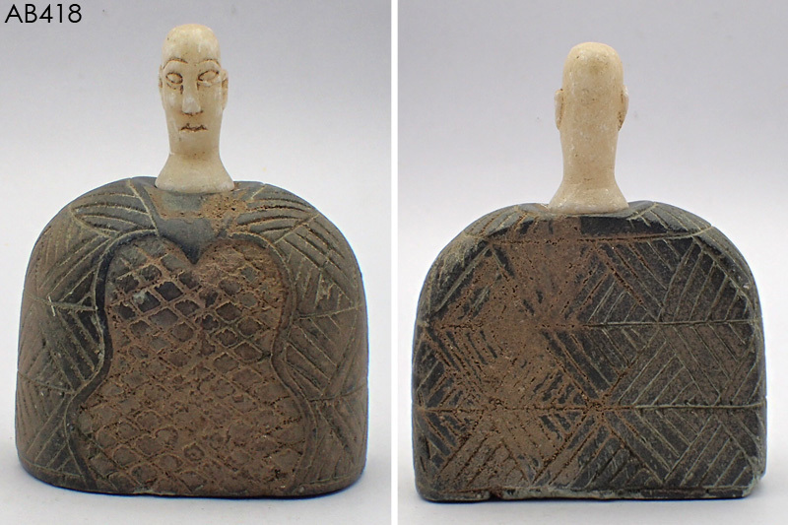

Bactria-Margiana composite chlorite and white calcite seated male, Middle to Late Bronze Age, 2000-1650 BCE